Customization User Manual
- General Information
Order | Xxx
Client | Sudheesh(vendor)
Technician | mick
Date | 2025/10/30
Model | / | Platform | /
Custom firmware |  | Custom software | BioCVSecurity6.6.2
Custom SDK Ver. | / | Operation System

- Requirements Description：
Function1：Need our BioCVSecurity to push the required data fields to the customer API in real-time for integration.
Payload Example:
Endpoint Information
· Method: POST
· URI: http://167.99.40.198/api/webhook/zkt-gateway
· Purpose: Record scanning on the gateways
Request Format
· Headers
· Accept: application/json
· Content-Type: application/json
· X-Signature: <secret> → This is a shared secret that we will provide; please send it verbatim.
· X-Timestamp: <unix_epoch_seconds> → Must represent Unix epoch seconds in Asia/Riyadh timezone and must not be in the future.
· Body (JSON)
{
"pin": "3232",
"door_id": "dr_3SSFbHGF78fGFJH",
"occurred_at": "1755525623",
"raw": {"any":"optional extra data"} // Any Extra Information
}
Validation Rules
· pin → required
· door_id → required
· occurred_at → required (timestamp)
· raw → optional (JSON)
Notes
· Please keep the X-Signature secret confidential.
· Ensure that the X-Timestamp is correctly generated and not in the future.
· Secret: "ZKT-8e51246bc92387fa49cdd67efb4d8205f420d3cb586a87157e27efde35b56b9c"
Fields Description:
-The pin will be the child_id or whatever the name of it , it will be
the person who owns the capability for entrance through the gate, and
basically we will generate the pin from our side using "create pin
endpoint".
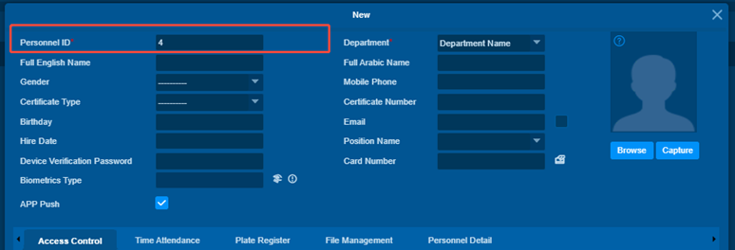
- The door_id will be the door serial which we can use to open it using
"open door by id endpoint".
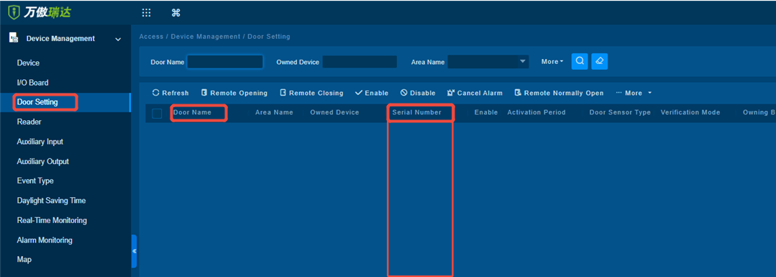
- The occured_at will be unix timestamp of the real time which the door
opened at.
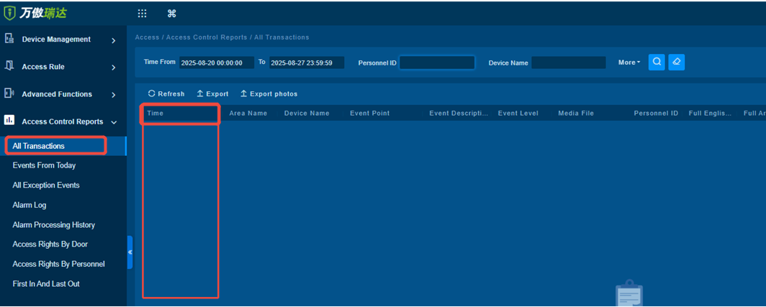
Note:raw is nullable , it can be any json metadata that can ZKT provide
for each event occurred.

Update and test steps
1. Backup customer databases and resource files
Resource files screenshot
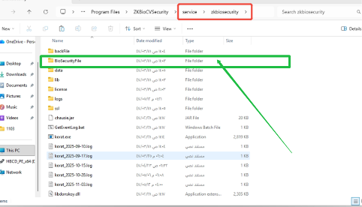
2. Successfully upgraded to mainstream software such as 662(this customer default version is 662)
3. Upgrade to the customized package and verify whether the customized content is displayed
4. If it does not display, place the script file in this path, execute it, enter the database password, and then check whether the customized content is displayed
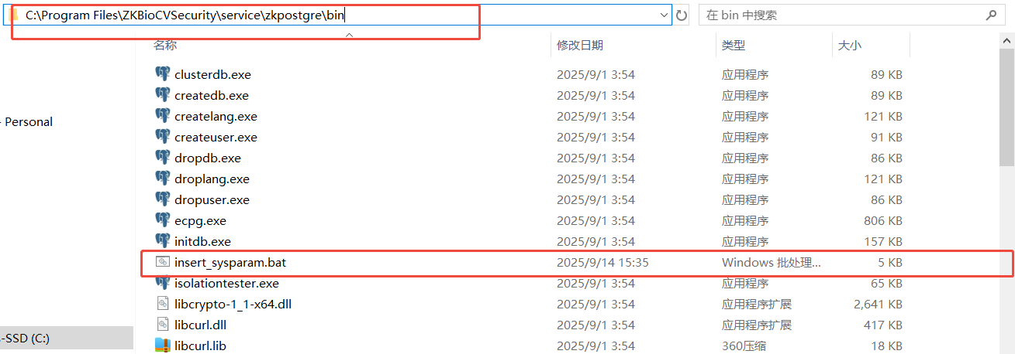

Function 1:
Description：Local push data to customer
New path: None
Instruction：
- Input the server link as following picture:
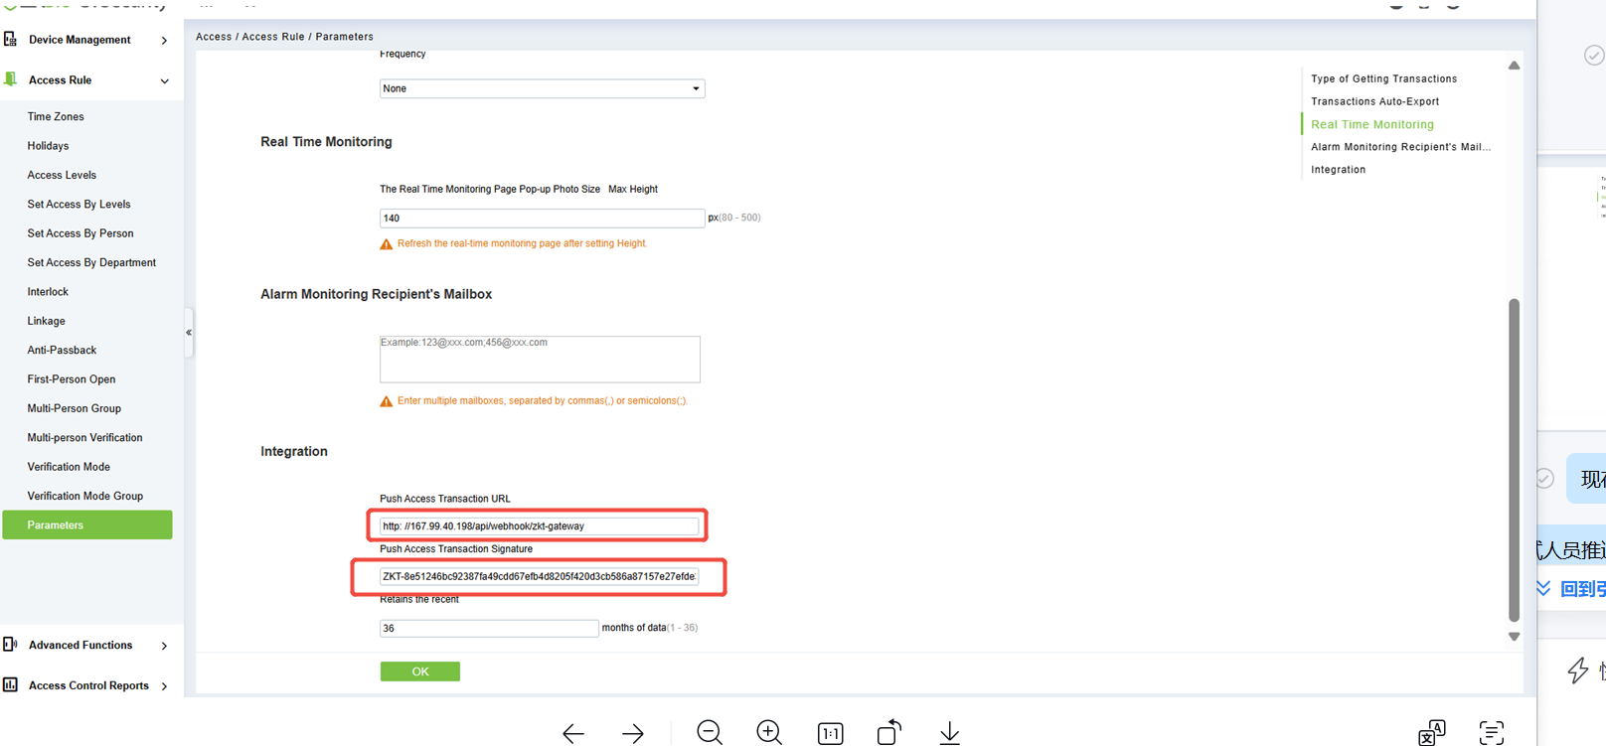
- Check the push data status. Result is ok.
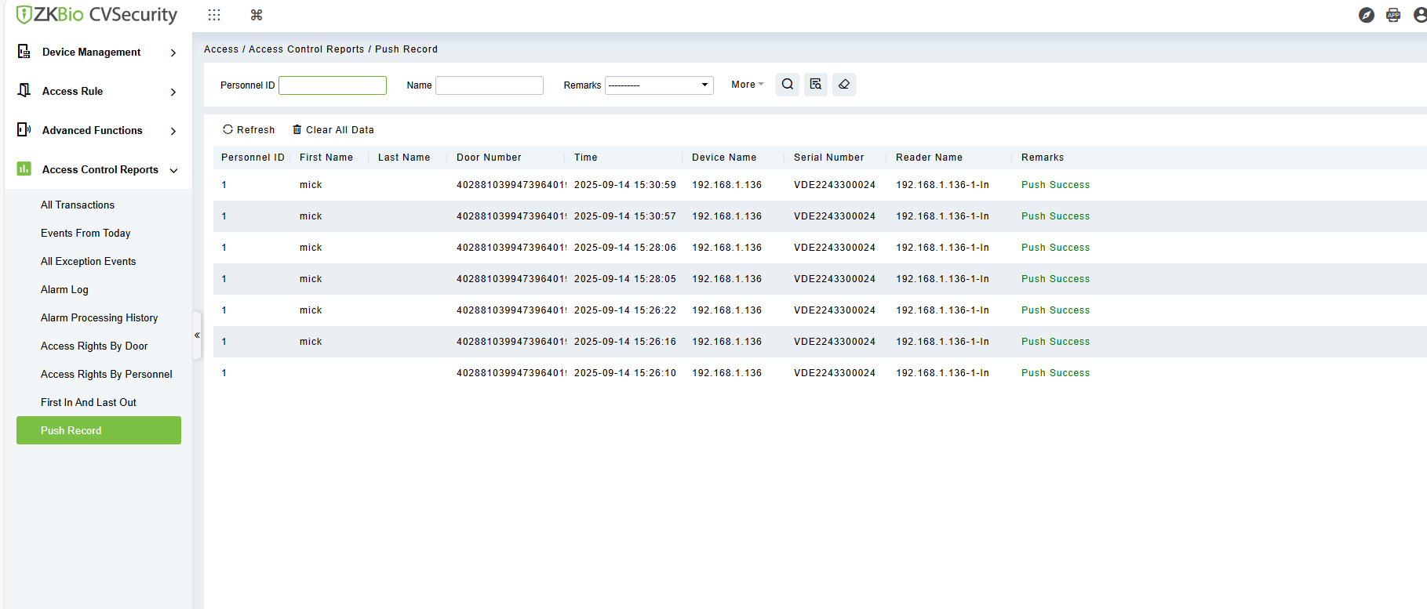

Finally application this customization for end-user ,push data function working properly.

Customization change (If there is any change of customization firmware in the future)
Date | 2025/11/1
Content
parameter
Language/voice
New menu
Technician

